1. After downloading the BM files from Github, double click to open the code in Berkeley Madonna.
2. Click the “Run” button, the single animal model takes about 10 seconds to run.

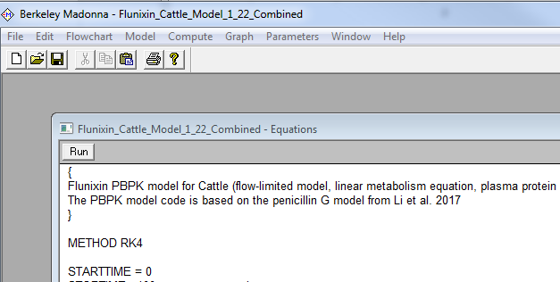

1. The result will show like the following

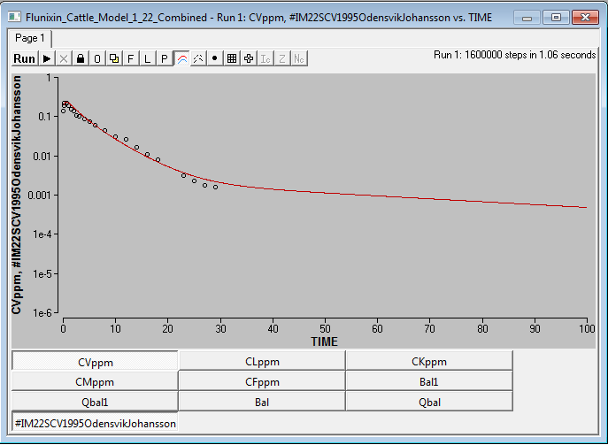

1. For the files with “PopAnalysis”, choose “batch run” from “parameters” tab.

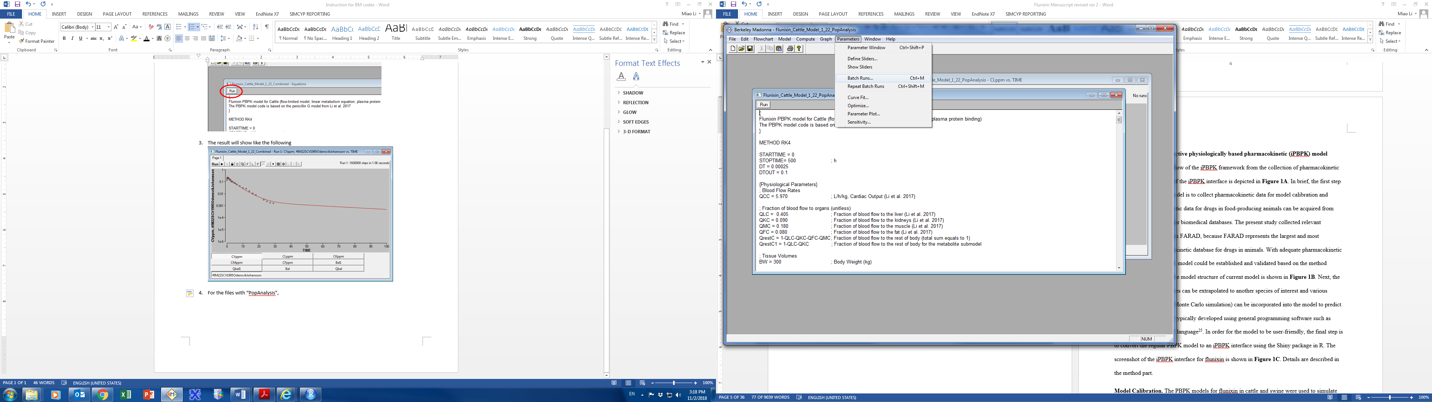

1. Set the number of runs to 1000, and click OK.

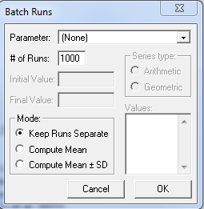

1. The 1000-time simulation may take from 2-12 hours to finish depending on the computer.